Coursera

**Neural Networks course**

*Week1*

1. We can build a simple NN in order to mimic a linear regression: size (x) -> neuron -> Price (y)
   1. The neuron will run the linear regression
   2. This NN is called RELU (Rectified Linear Unit)
      1. Rectified stands for that it never goes below zero (like prices)

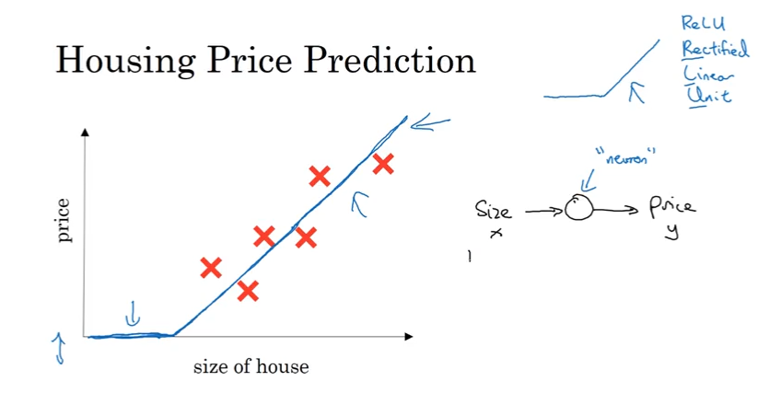

1. Multinomial Regression (few IVs) you can build a NN with few neurons and layers

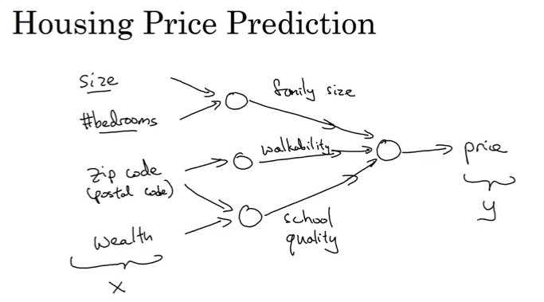

1. We can let the NN to decide the connections itself (instead of creating “family size” from two vars)

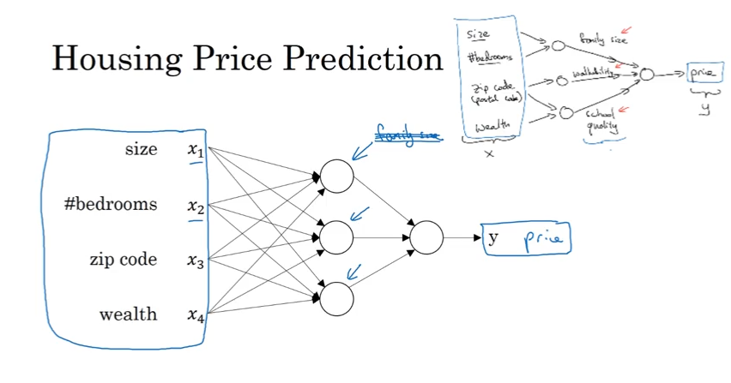

1. Supervised Learning NNs
   1. Linear/Logistic regression – Standard NN
   2. Images – CNN (Convolutional NN)
   3. Audio (Text transcript) / Translations – RNN (Recurring NN) – used for sequences
      1. Supervised learning (very efficient too).
   4. Automatic cars- You will need something more complex

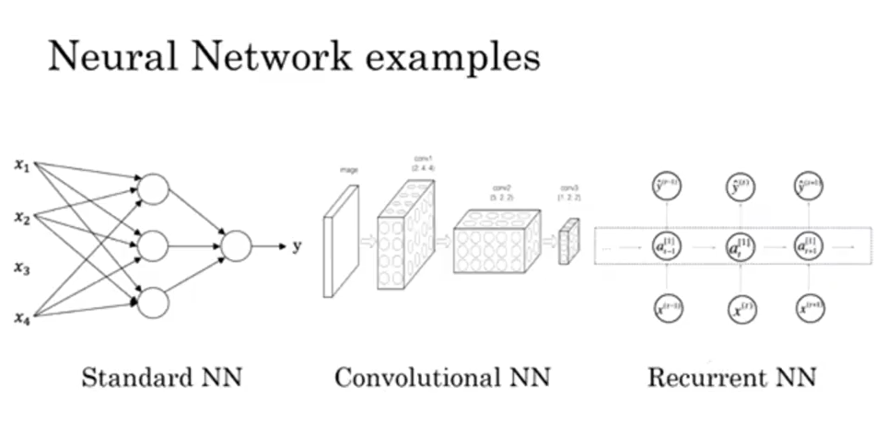

1. Structured vs unstructured data
   1. Humans are good in understanding unstructured data while it is very hard for a computer

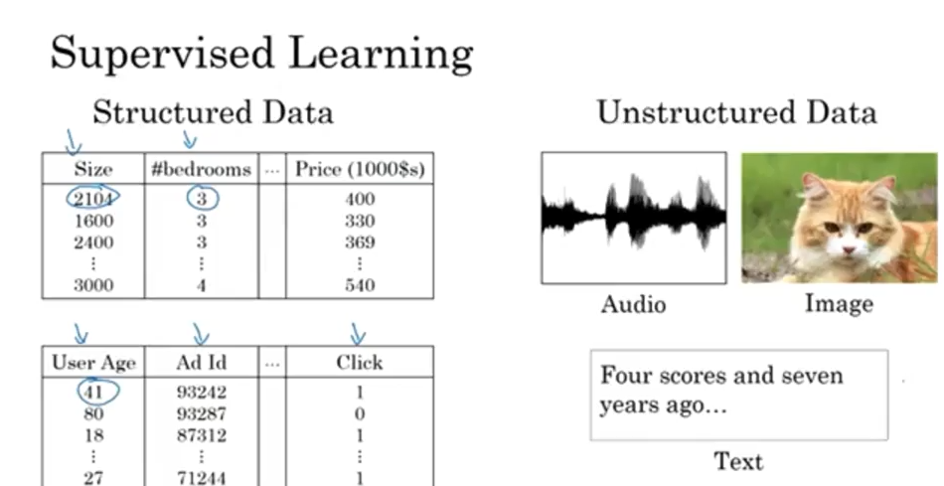

1. Why NN?
   1. Because unlike the traditional ML models they continuously improve with (labeled) data

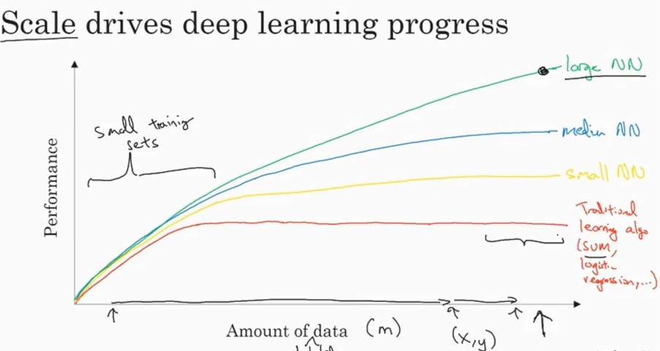

* 1. For small training data the normal ML methods are competitive
  2. Data/Computation/Algorithms made it possible to grow NN easily (switching from sigmoid to ReLu for instance make training the network much faster as the gradient isn’t near to zero and hence, GD works much faster)
  3. Faster computation made it easier to train networks fast and experiment new ideas

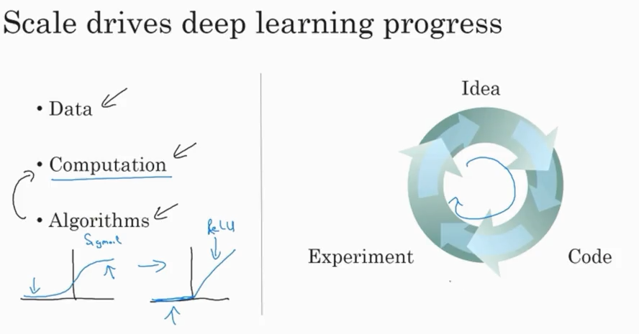

------------------------------------------------------------------------------------------------------------------------------------------

***Week2***

1. Binary Classification
   1. Cat -> yes/no
   2. The computer uses RGB matrices in order to identify pictures
      1. We convert all these vals into a long vector X which is an IV

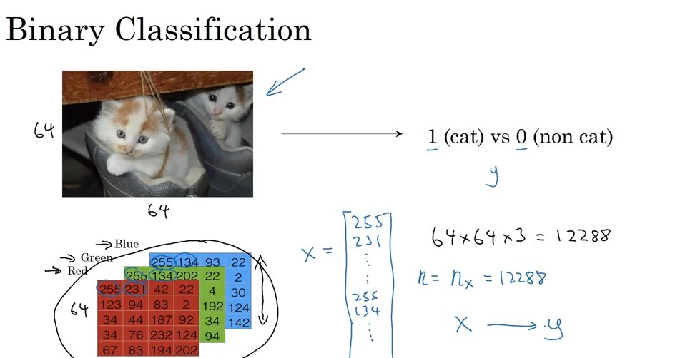

Notation

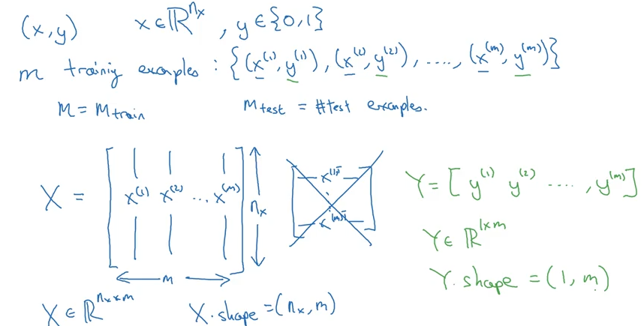

1. Logistic regression
   1. Loss function: Square error is not so good as it is not convex and GD works bad with it
   2. Hence we are defining another loss function (similar to Bernoulli formula)
   3. **Loss Function** is for one observation, **Cost function** is the average of all the loss Functions

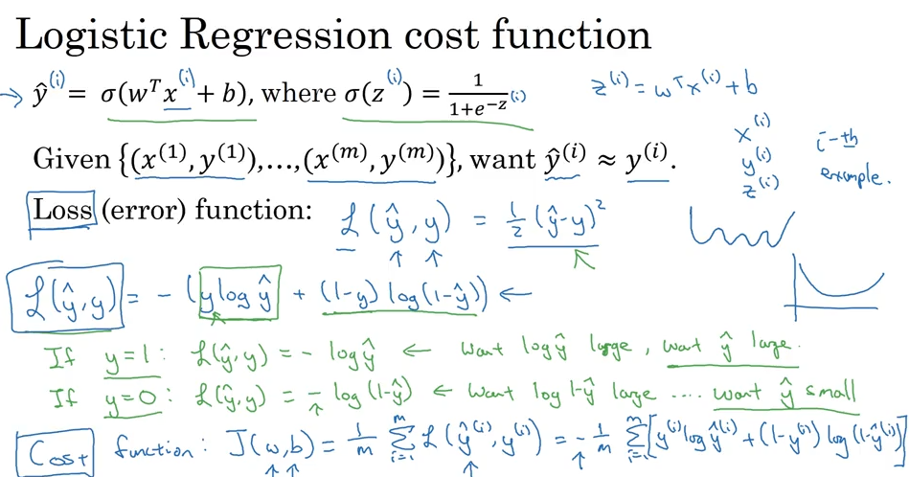

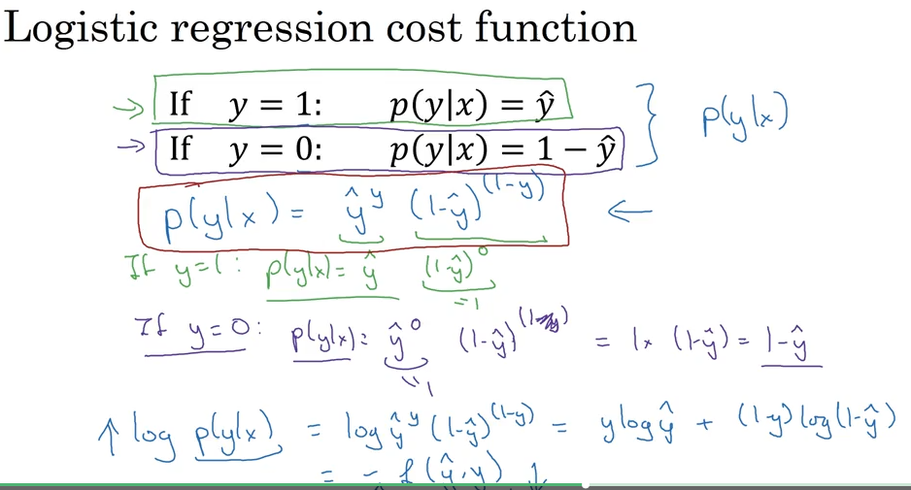

1. Gradient Descent
   1. We want to find w, b that minimize the Cost Function.
   2. We can do that easily because the Loss Function is convex

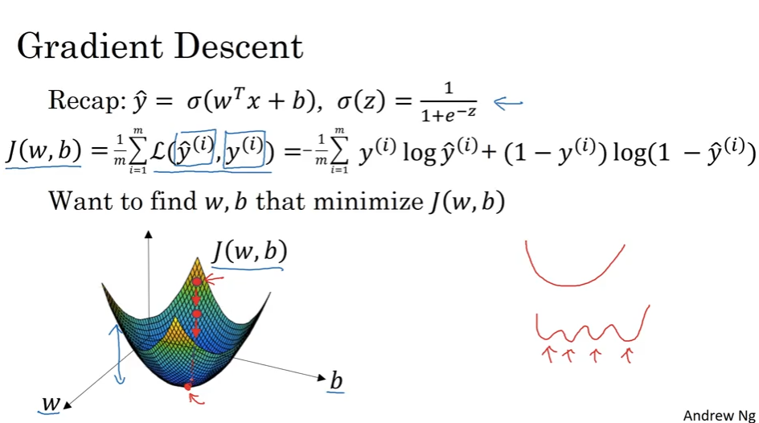

1. Derivatives
   1. Intuition
      1. **Derivative is just the slope** = which is the height divided by the width (change in Y divided by the change in x)

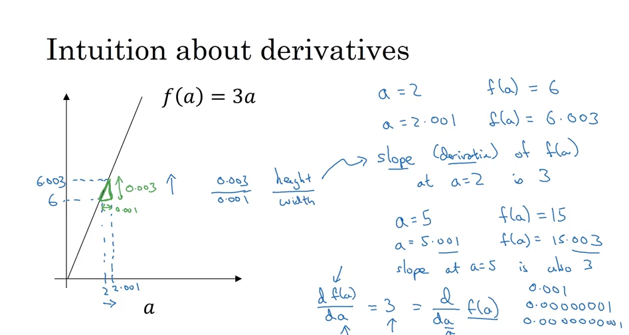

* 1. Examples:
     1. For non-linear functions the slope changes for different values of x

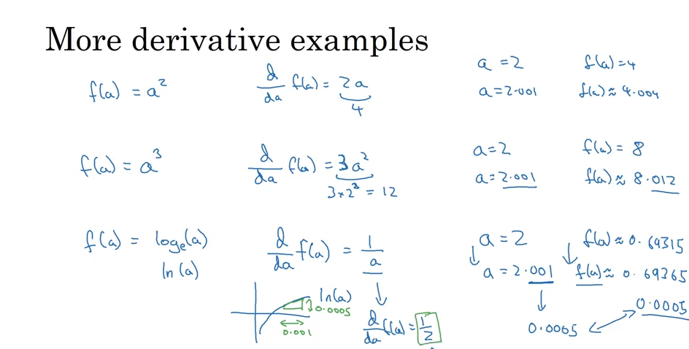

1. Computation Graph

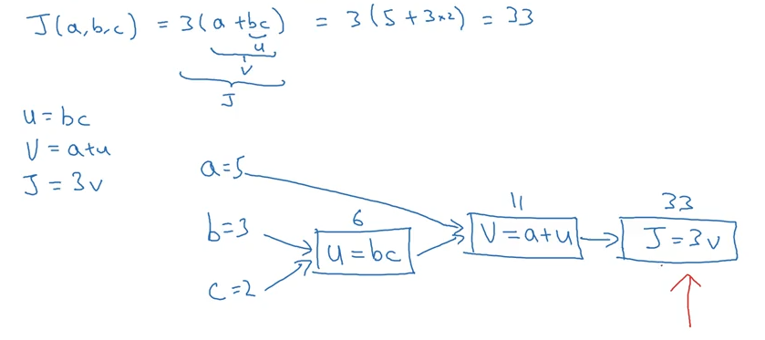

1. Computing derivatives is also called **back propagation** (using the chain rule)

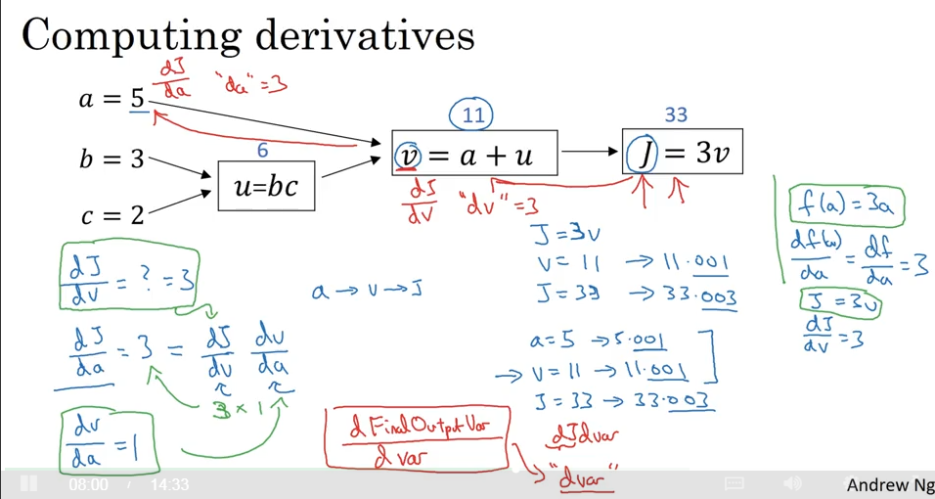

1. **Computation Graph** / **back propagation** in LR for the **cost function**

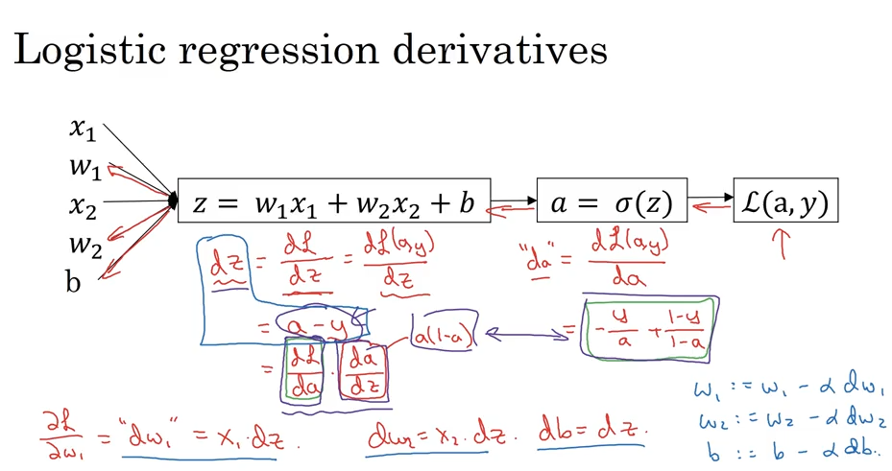

1. **Computation Graph** / **back propagation** in LR for the **Lost function**
   1. This runs two for loops. Instead we could vectorize it

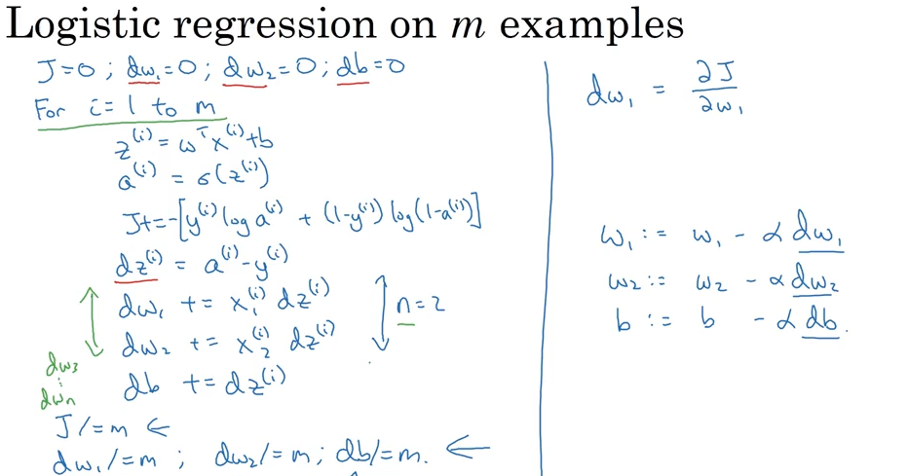

1. **Vectorization** (getting rid of for loops in order to achieve speed)

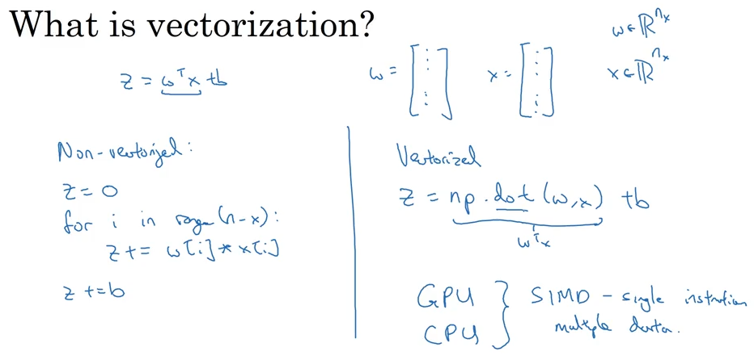

* 1. Vectorization for Logistic Regression

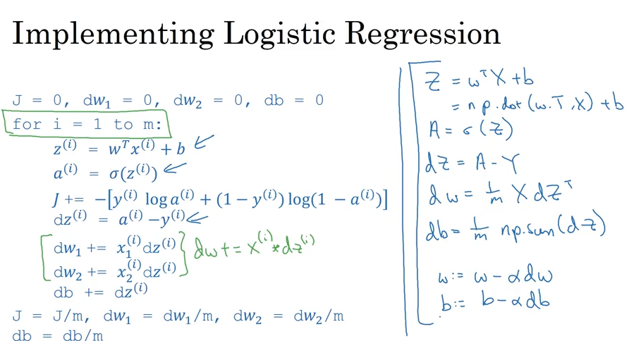

1. Broadcasting (basically vector recycling in R)

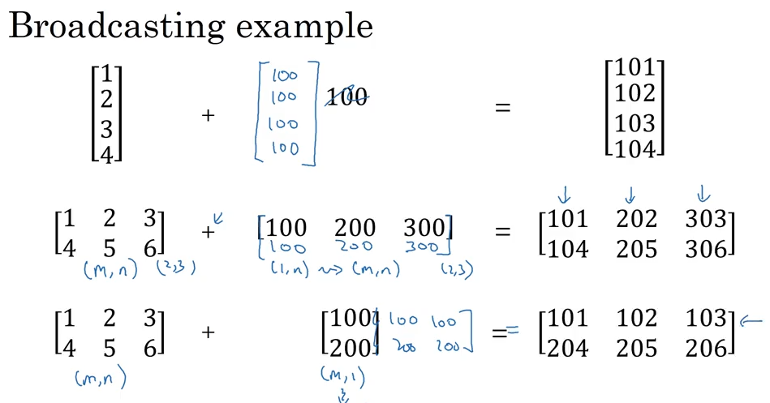

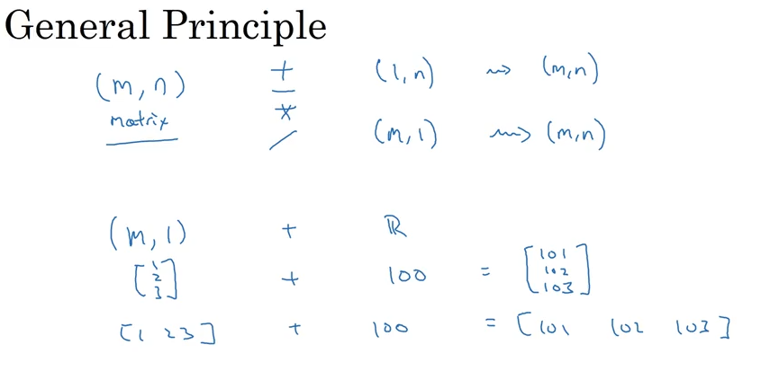

1. Notes about numpy vectors/matrices

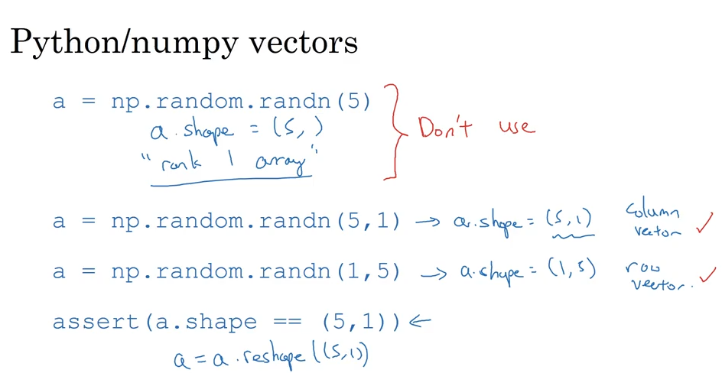

------------------------------------------------------------------------------------------------------------------------------------------

***Week3***

1. Implementing a NN
   1. One hidden layer NN vs Logistic regression
   2. In a NN we go backwards
   3. Also, there are two steps

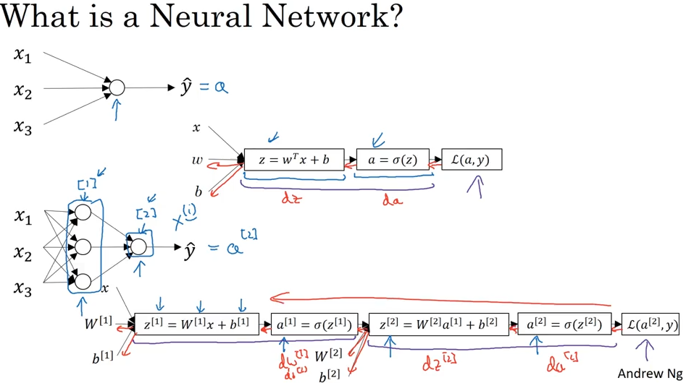

1. NN Representation
   1. Input layer
   2. Hidden Layer (we don’t see it in the training set)
   3. Output Layer
   4. X = Input =features
   5. a[0] = Activations (input layer)
   6. a[1] = Activations (hidden Layer) = the feature vector
   7. a[2] = Output Layer = Y_hat
   8. The hidden layer will have w[1] and b[1]
   9. The output layer will have w[2] and b[2] associated with it

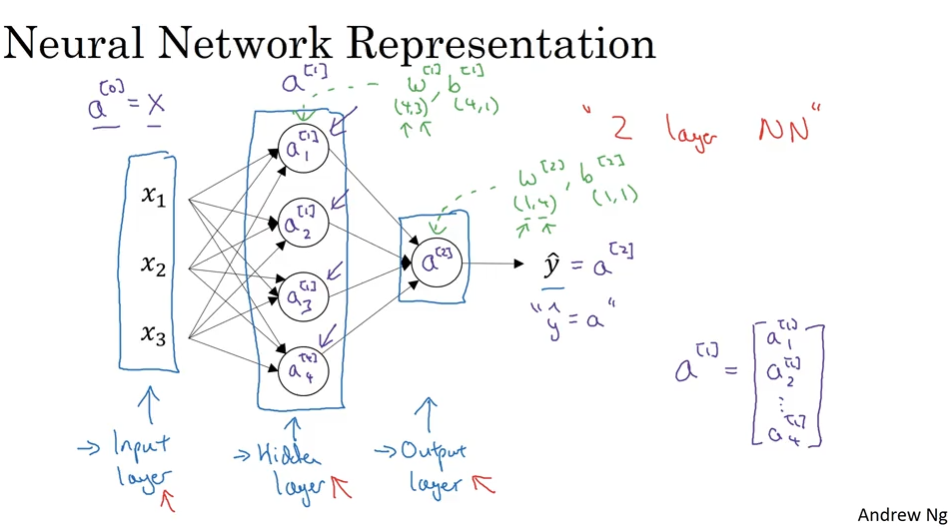

1. The NN similarly to the LogReg will compute z and a, but it will do this for each node in the hidden layer

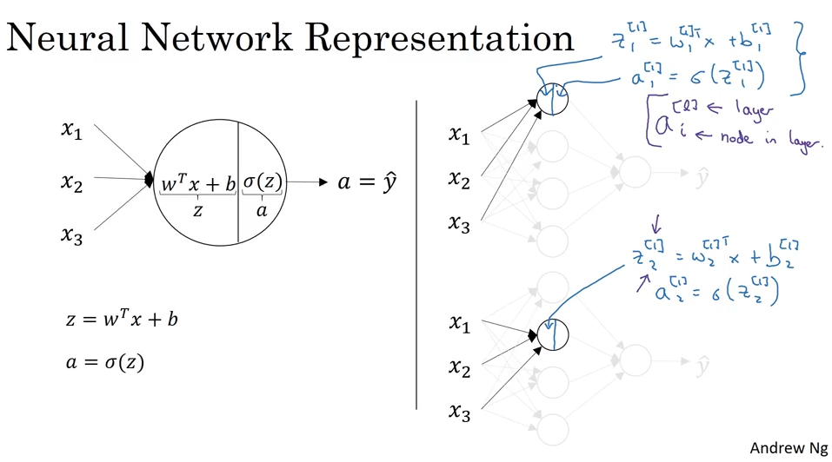

1. Vectorizing z computation for all nodes at once.
   1. You basically do a matrix multiplication

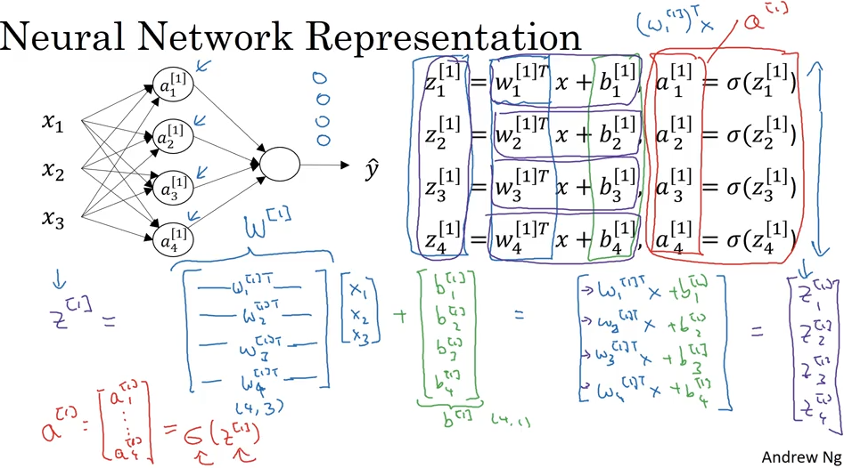

1. Basically computing LR for hidden layer (z[1] & a[1]) and then for the output layer (z[2] & a[2])

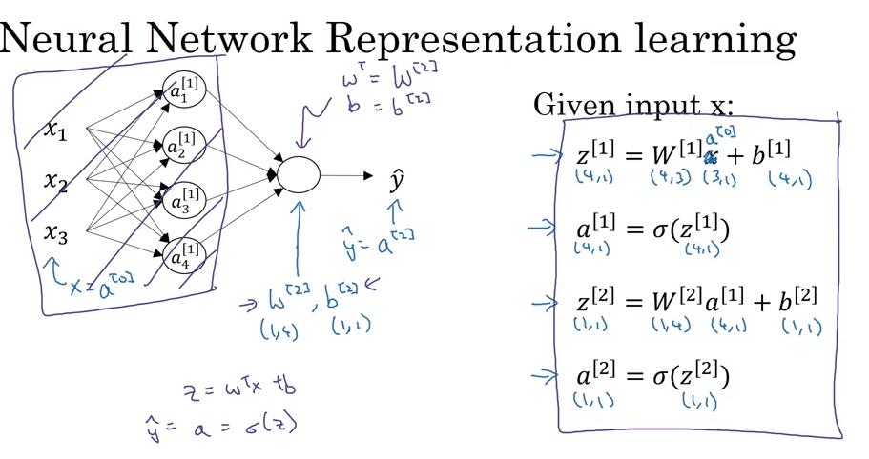

1. Vectorization over multiple examples
   1. We want replace the for i = 1 to m loop:

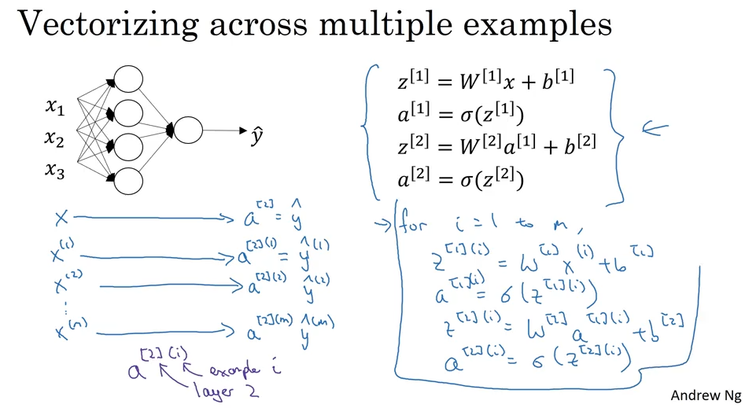

* 1. So we will create capital Z[1], A[1], A[2] and Z[2] by working over capital X by stacking all the x vectors horizontally (horizontally we are going over different training examples, while vertically we are going over different features (notes))

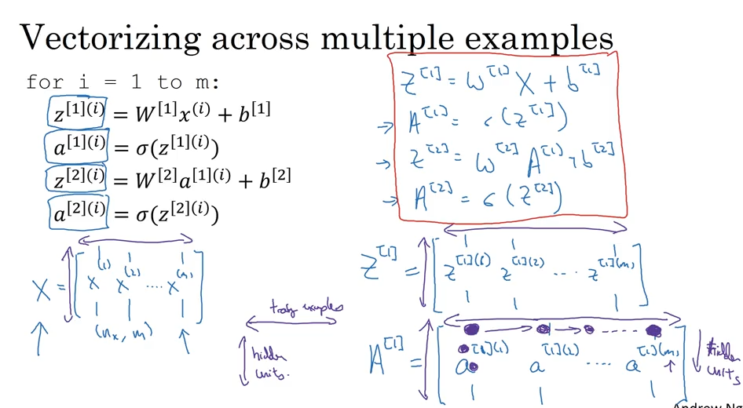

1. Vectorization justification

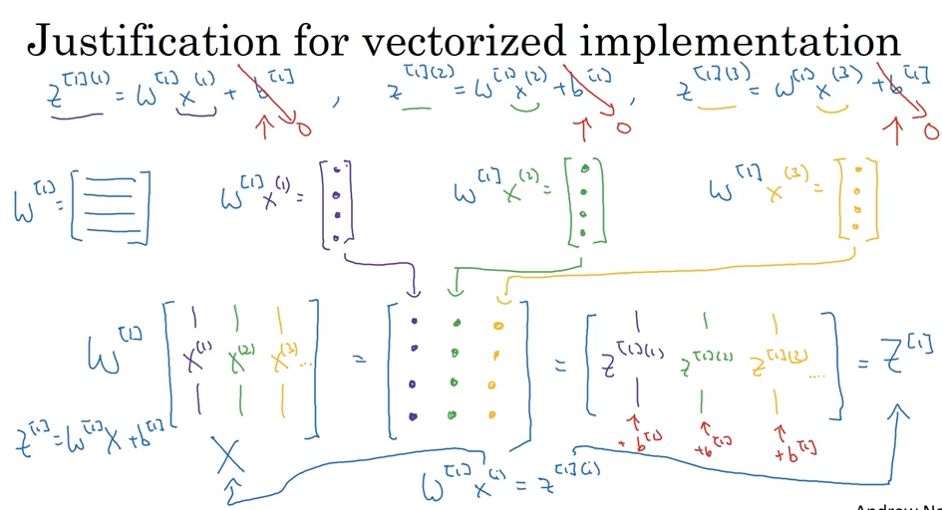

So to recap:

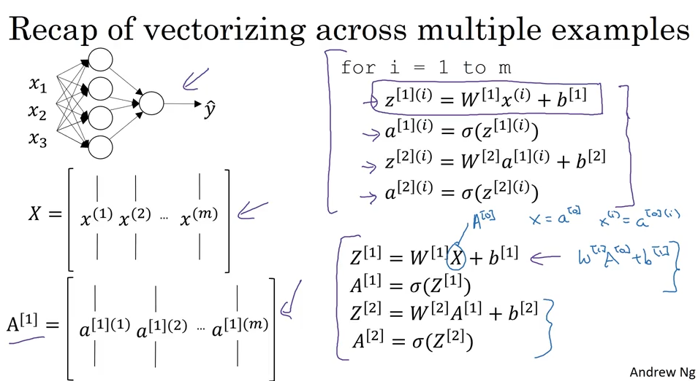

Even the deepest networks are basically doing the same calculations over and over.

1. Activation functions
   1. So far we used a sigmoid as an activation function
   2. Another alternative is the **tanh(z) function : (e^z – e^-(z)) / (e^z + e^(-z))**
      1. This function is almost always superior over the sigmoid
      2. Although when y is binary, it is better to use the sigmoid for the output layer because it ranges between 0 and one as opposed to tanh which ranging between -1 to 1
         1. **Hence, activation functions can be different for different layers**.
      3. If z is very low/large, the gradient/slope is very small and hence it slow down the gradient descent greatly
         1. Hence, we have an alternative function: **RELU (rectified linear unit): a = max(0, z)** which is not differential at zero, but it is pretty much impossible to get a z == 0 with floating points so we shouldn’t worry about it.
         2. There is also the Leaky **RELU (max(0.01z, z))** which has a slight slope on the left goes to the negatives so it won’t be zero.
      4. **The RELU considered to be the best activation function**

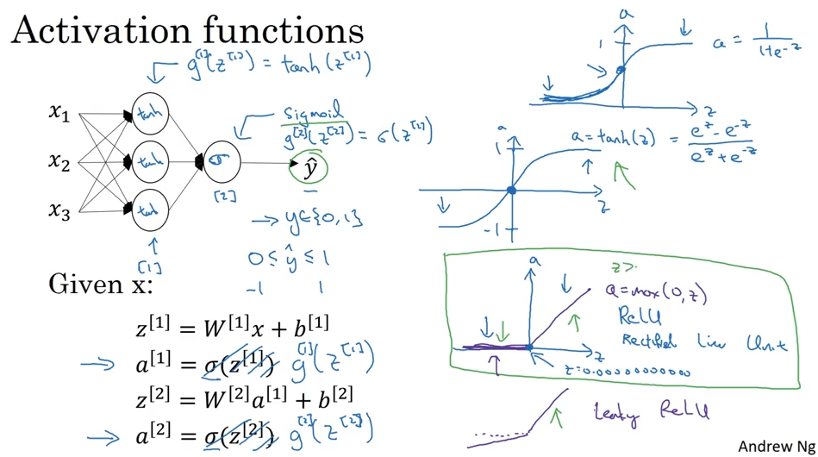

* 1. So to recap:
     + 1. For binary classification use sigmoid
       2. For everything else use RELU

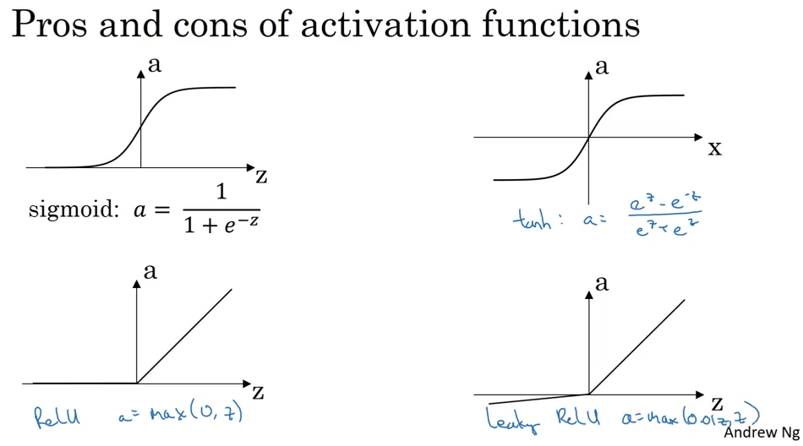

1. Why do we need non-linear function instead of just linear function? Because a hidden linear layer is useless as a combination of linear is also a linear function.
   1. You could use a linear activation function in the **output layer** in case y a continuous value between –infinity and +infinity
   2. If the y is continuous and positive, then you can just use RELU instead

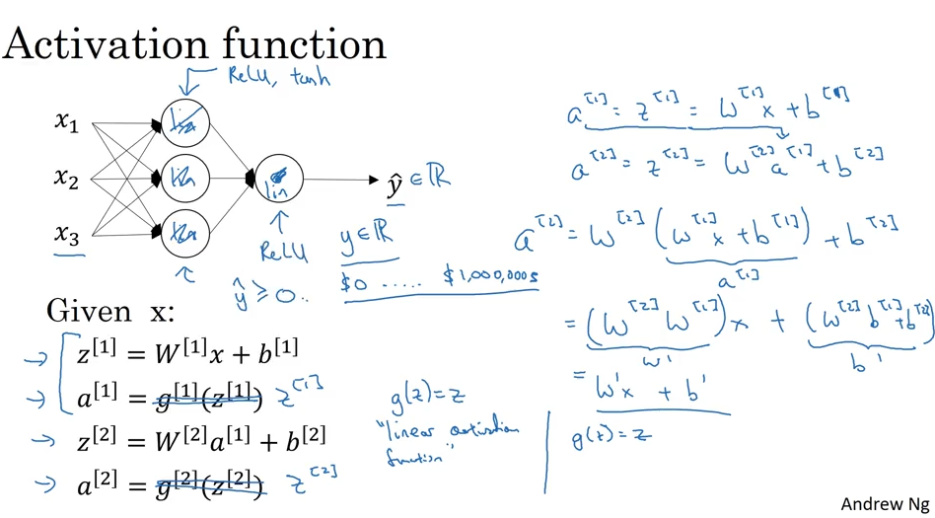

1. Derivatives of activation functions
   1. Sigmoid:

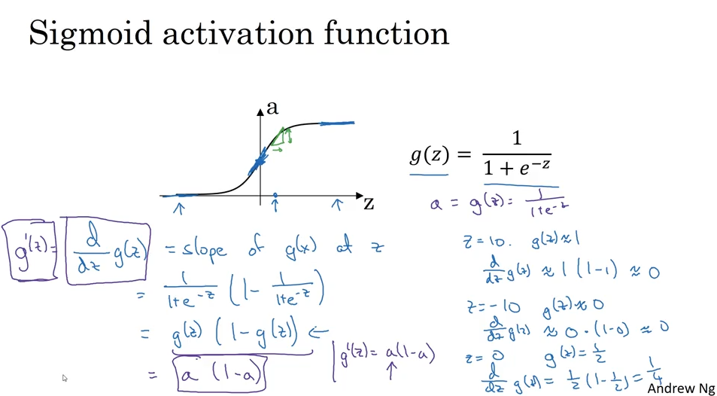

* 1. tanh

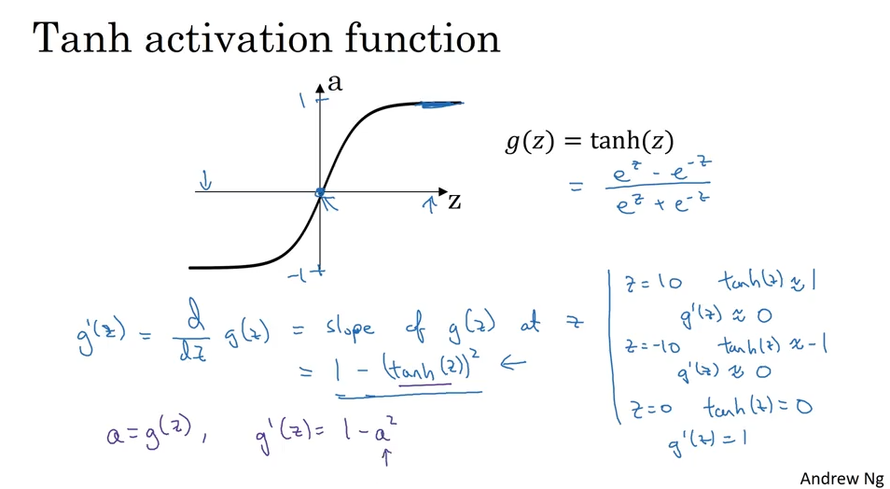

* 1. RELU/Leaky RELU

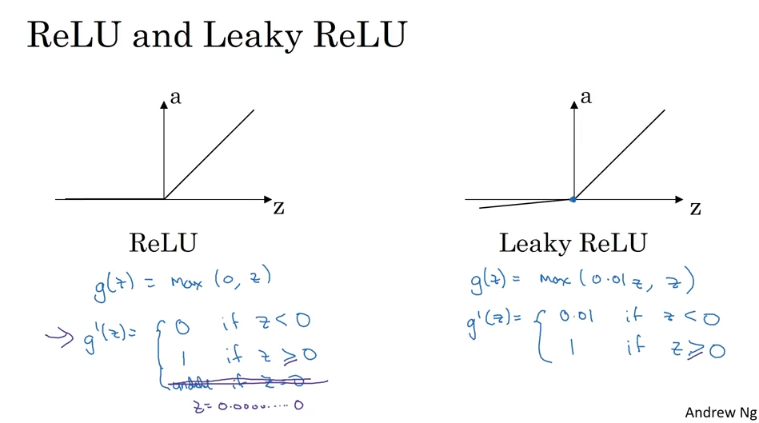

1. GD for NN
   1. We basically compute derivative for each of the layers in a loop

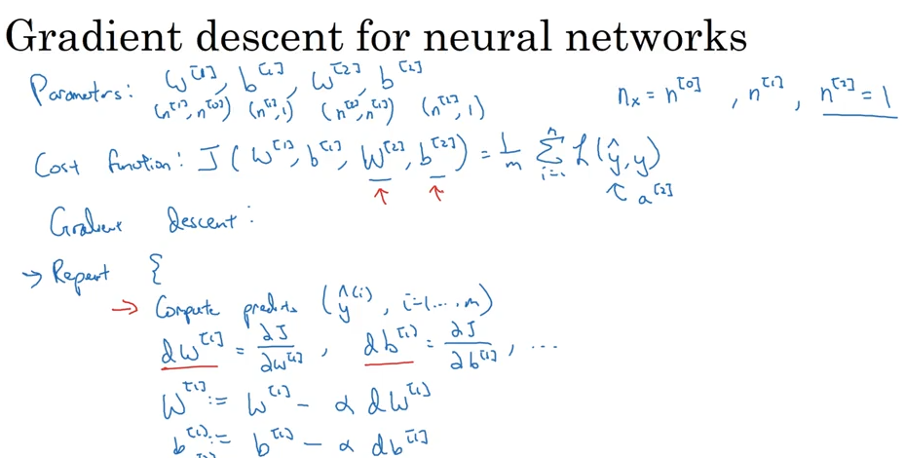

1. Forward/Backward propagation
   1. Forward is calculating the sigmoid (activation func) while using the previous layer as the x vector
   2. Backpropagation is calculating gradients while taking the previous gradients as the input

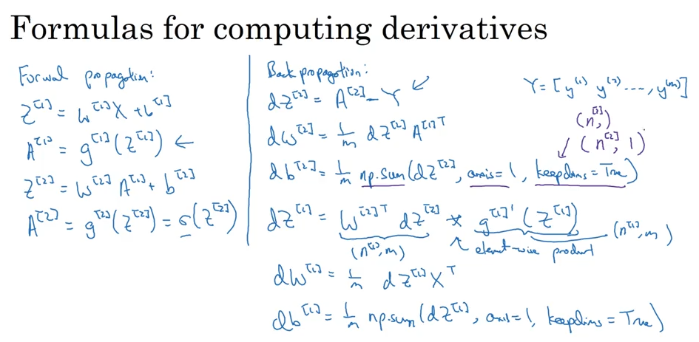

* 1. In LogReg it is one step

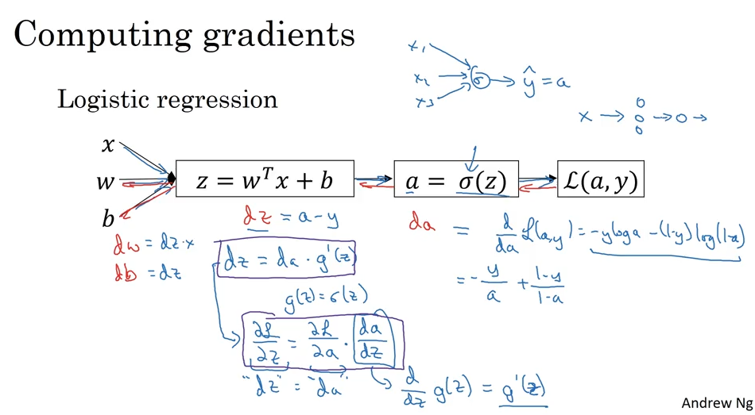

* 1. While in NN (with n layers) it is n steps which you can actually vectorize into one step

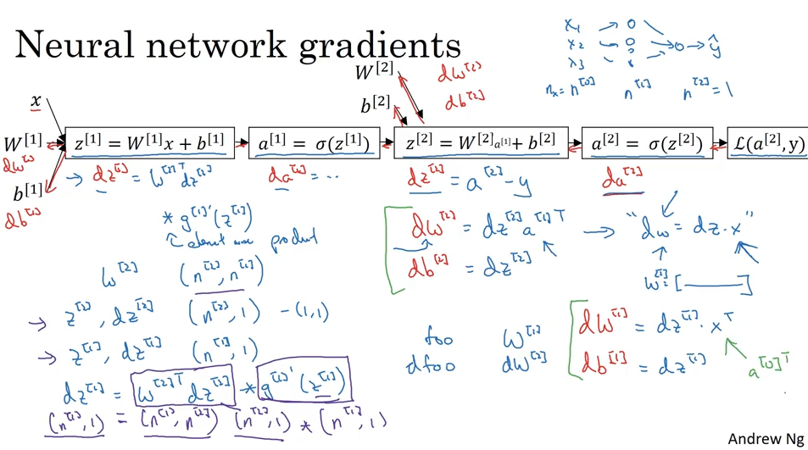

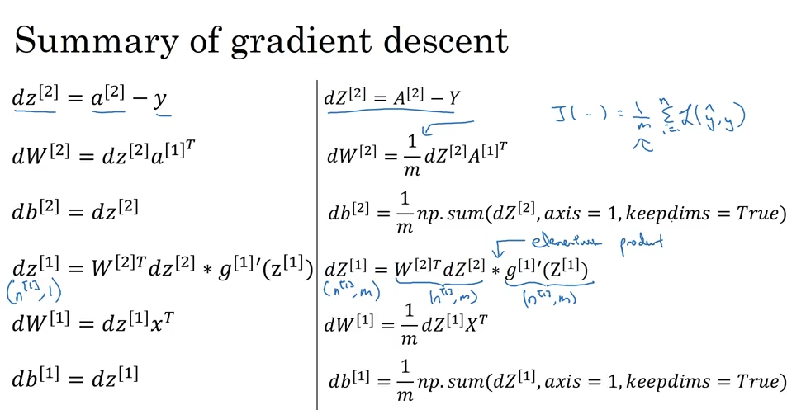

1. Random Initialization
   1. It is important in NN to do it randomly than just putting zeroes because if you have a zero matrix in w1, then a1 and a2 and also w2 will be equal to w1 hence there is no point in layers as all of the layers will compute them function

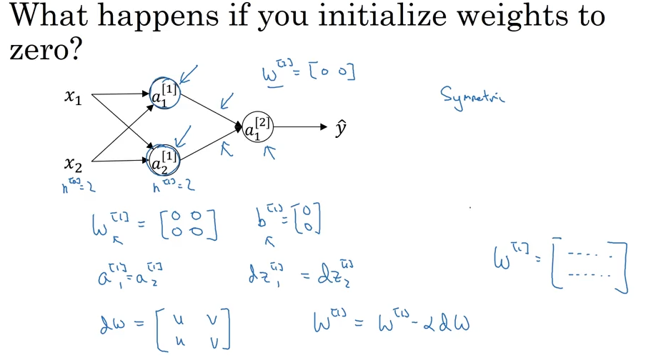

* + 1. Hence we initialize them randomly and multiply by a small number in order to make the values small so we won’t end up on the sigmoid tails where the slope is small and the learning is very slow

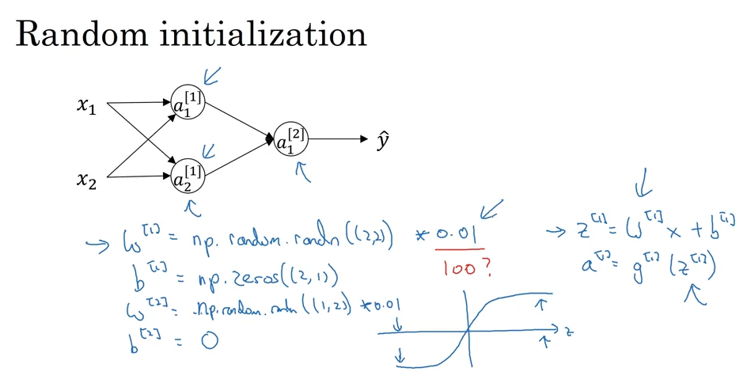

------------------------------------------------------------------------------------------------------------------------------------------

***Week4***

1. Deep L-layer NN

* A Deep NN is just a NN with few layers (we count hidden layer + output layer)
* Input layer is “layer 0”

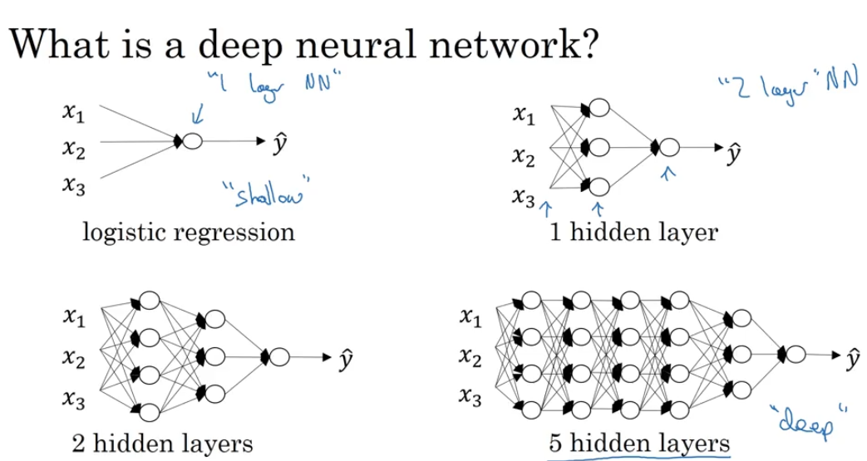

1. Notation
   1. “L” is the # of layers
   2. “n” is the # of nodes in a layer
   3. n[0] = nx = input layer
   4. “a” is the activation function
   5. “w” are the weights
   6. “z” = w*x + b
   7. “a[L]” = Y_hat

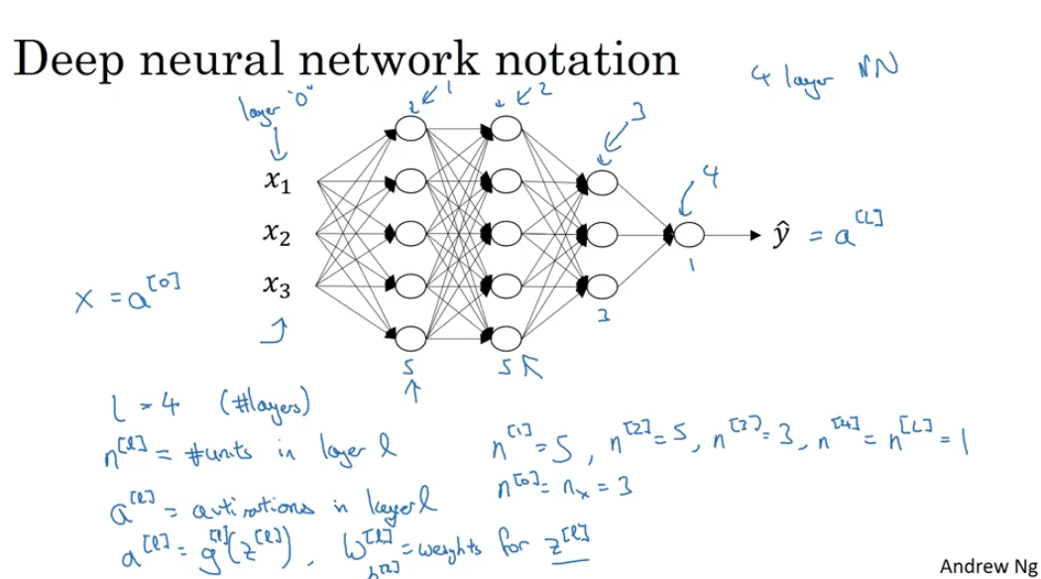

1. Forward propagation in deep NN
   1. Z[1] = W[1]*A[0] + B[1] ,…, Z[L] = W[L]*A[L-1] + B[L]
   2. A[1] = g[1](Z[1]) ,…, A[L] = g[L](Z[L])
   3. Z is a matrix of z[1][1]:z[1][#of nodes in layer 1], z[2][1]:z[2][#of nodes in layer 2], etc.
   4. There is no known way to run this without a for loop with the number of layers in the NN

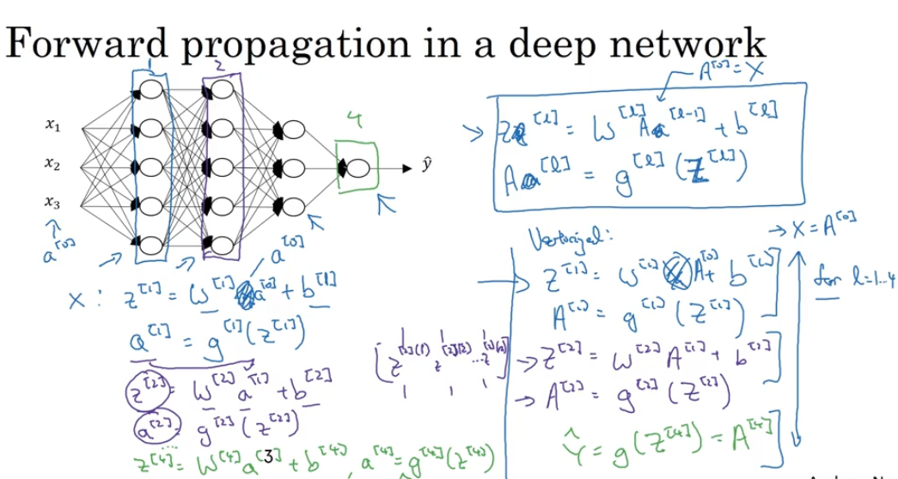

1. Matrix dimensions in NN
   1. w[1] : (n[1], n[0]) … W[l] : (n[l], n[l-1])
   2. b[l] : (n[l] , 1)
   3. dw[l] : (n[l], n[l-1])
   4. db[l] : (n[l] , 1)

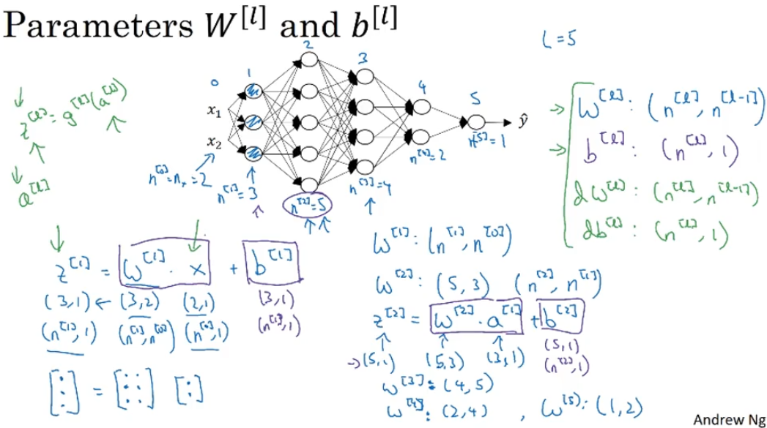

1. The vectorized implementation will have a bit different dims
   1. Z[1] : (n[1], m) (m is # of obs)
   2. W is the same
   3. X : (n[0], m)
   4. B : (n[1], m)
   5. dZ[1], dA[1] : (n[1], m)

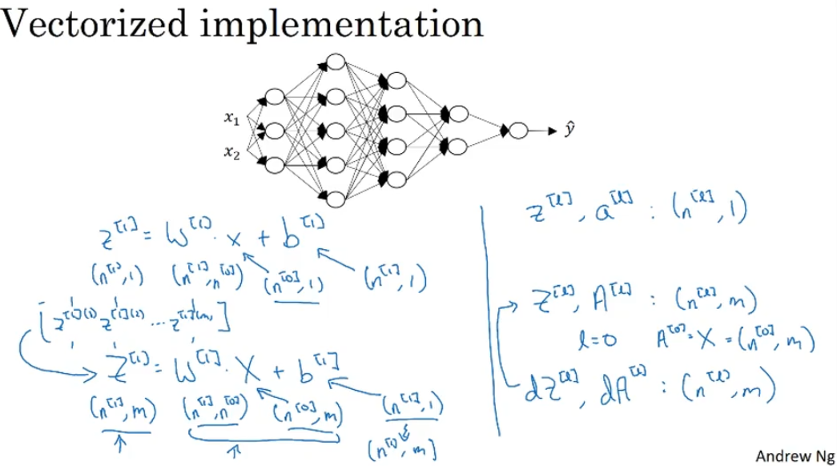

1. Why do we need deep NN?
   1. In CNN – image recognition: Simple to complex
      1. Each layer does different part, e.g.,
         1. first layer identifies edges/features,
         2. Second layer groups edges together into parts of face,
         3. 3d layer combines different parts of faces into different types of faces while final layer will be the decision one.
         4. Each layer looks at different size of the image
   2. In Audio – same idea of simple to complex:
      1. Low/loud
      2. Phonemes
      3. Words
      4. Sentences/phrase

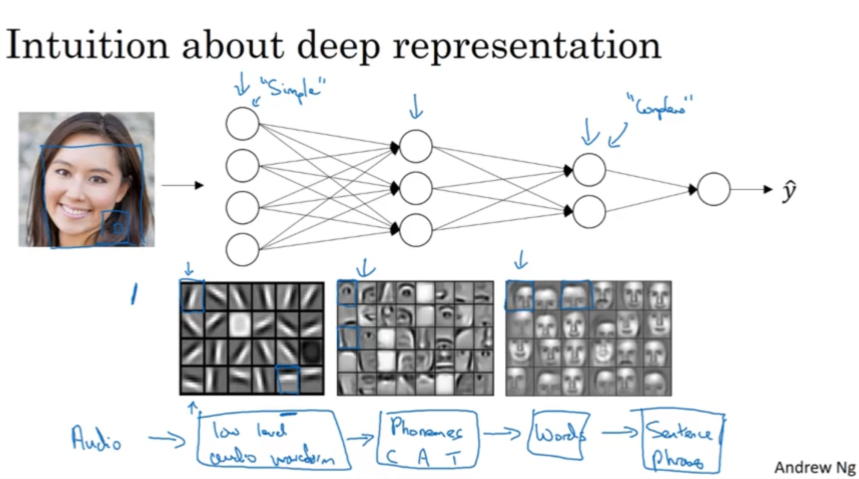

1. Circuit theory and DL
   1. You can compute stuff with small amount of layers but a lot of nodes instead but that will worsen the things

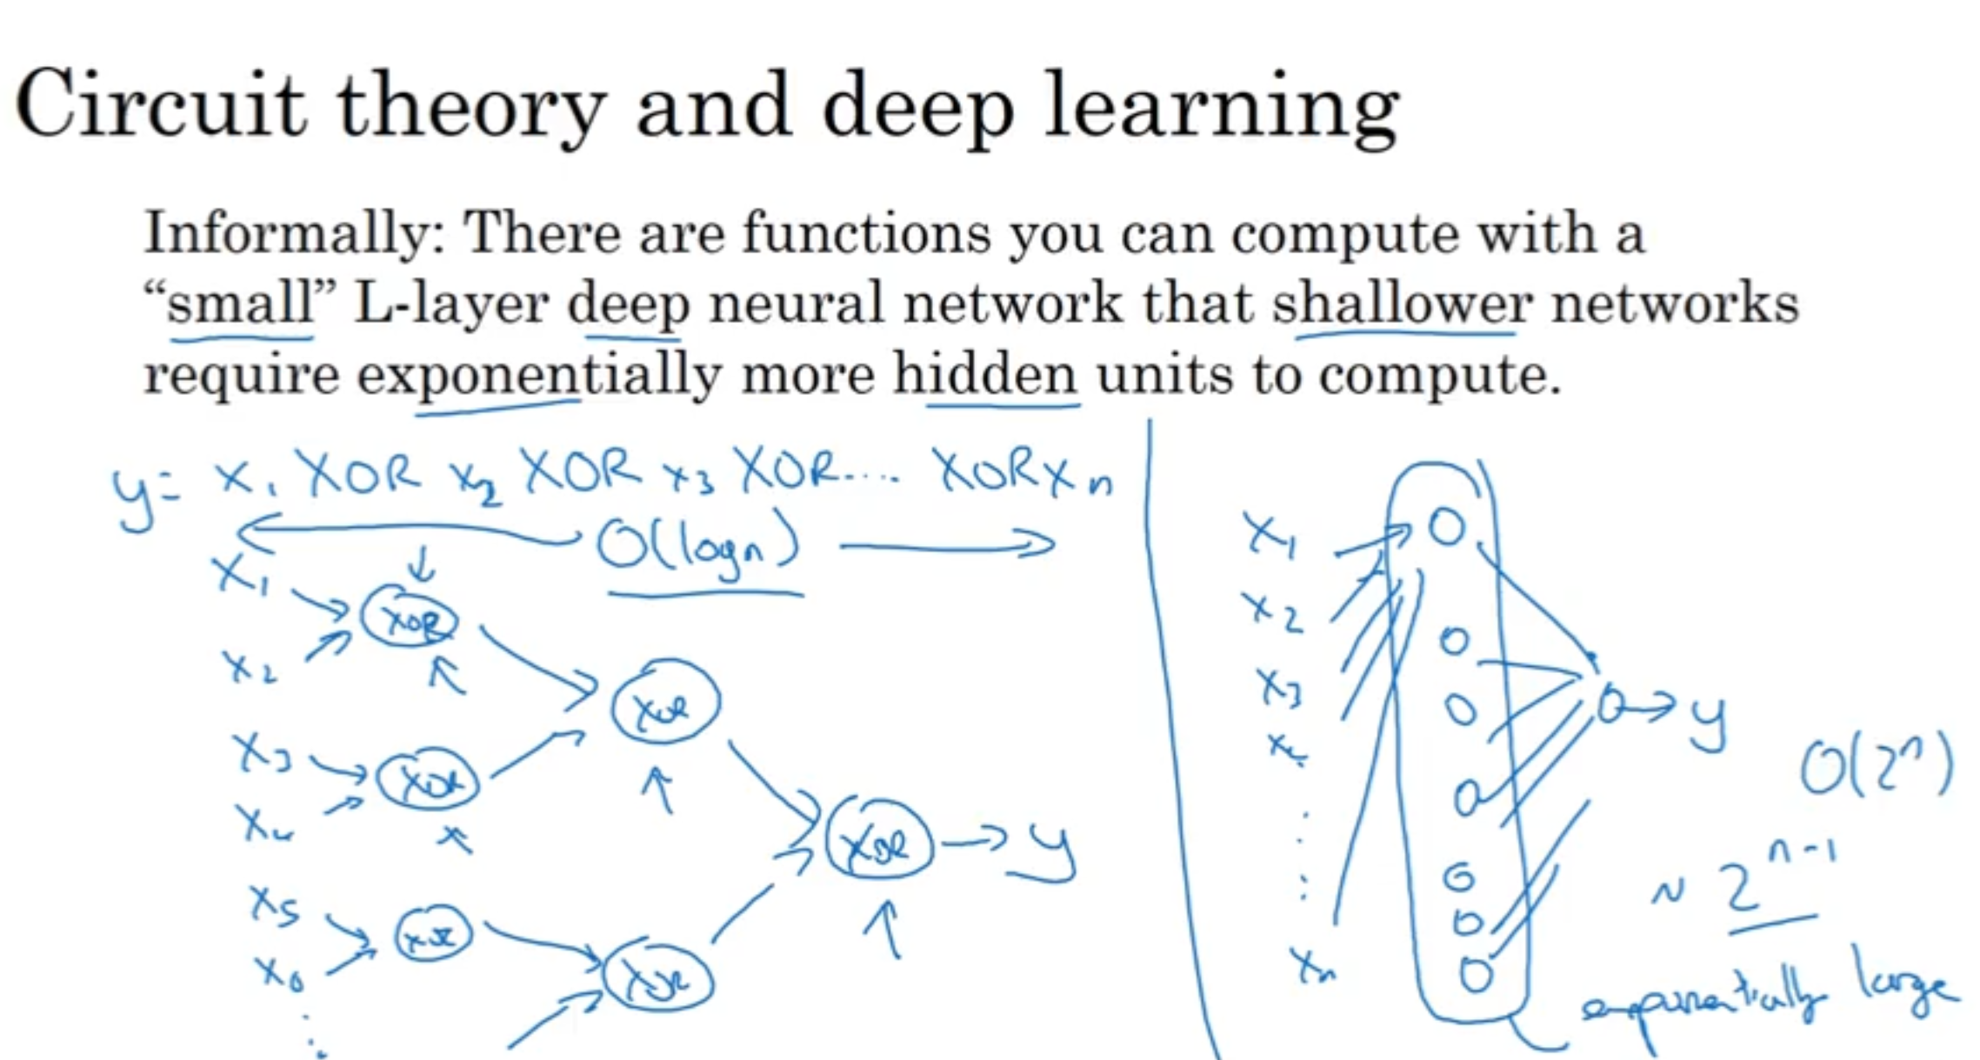

1. Back/Forward prop for DL
   1. Forward prop
      1. Z[l] = W[l]a[l-1] + b[l]
      2. A[l] = g[l](Z[l])
      3. It is useful to cache Z[l] for back prop
   2. Back prop
      1. Input da[l] (uses cached Z[l])-> output da[l-1], dw[l], db[l]

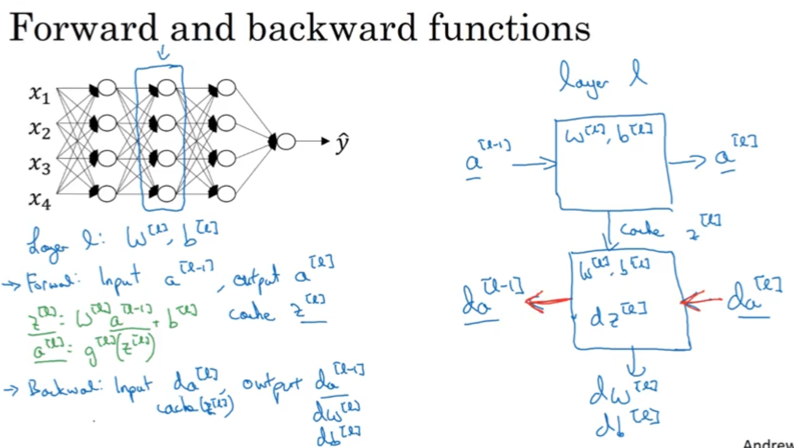

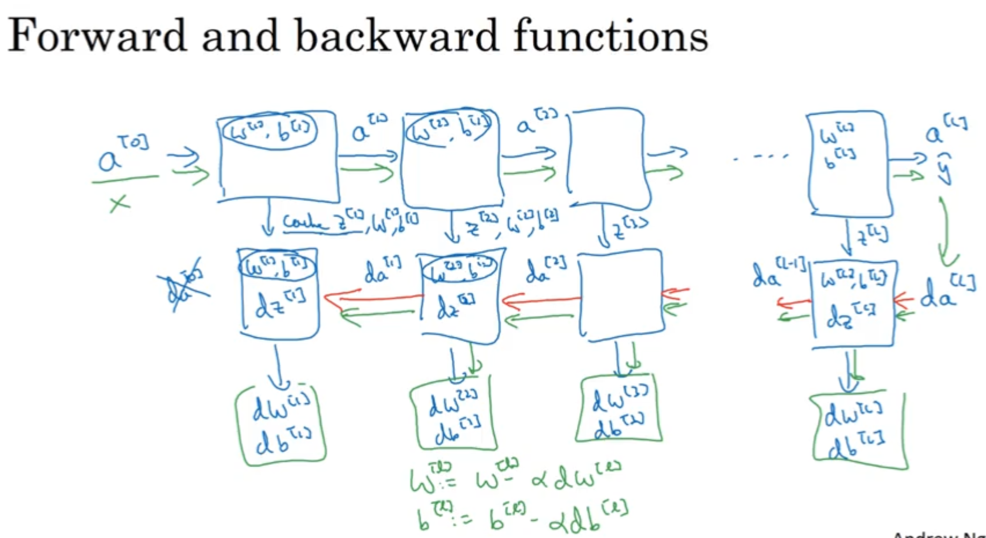

* 1. Forward Prop cpnt.

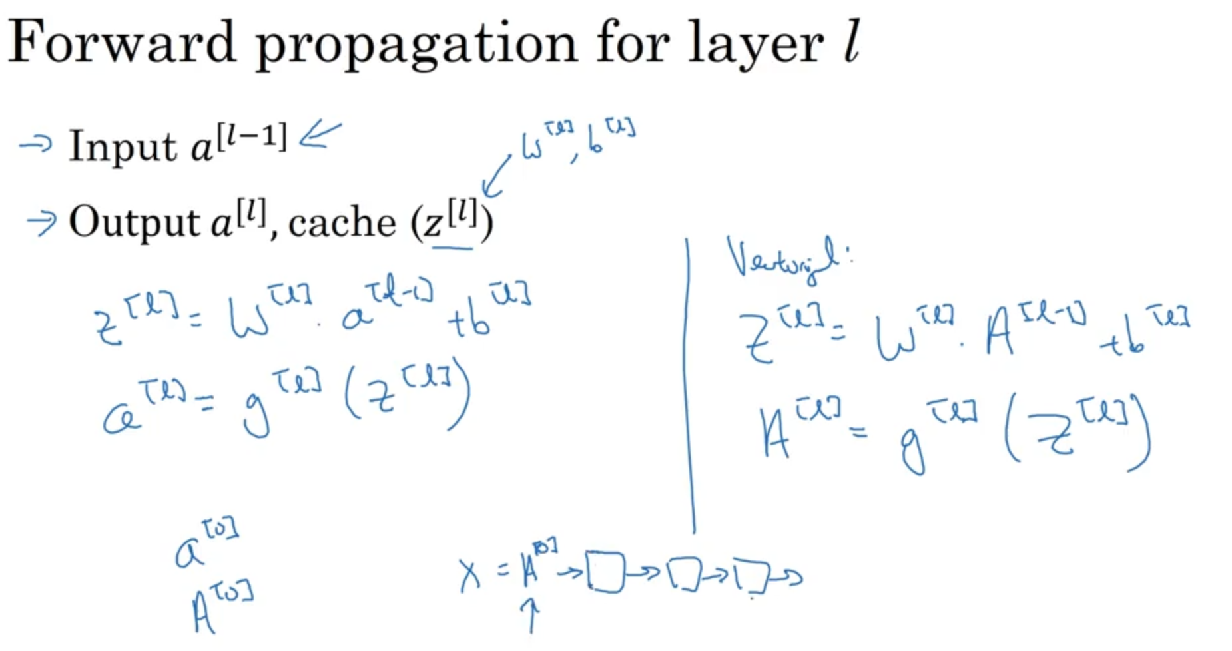

* 1. Back Prop. Cont

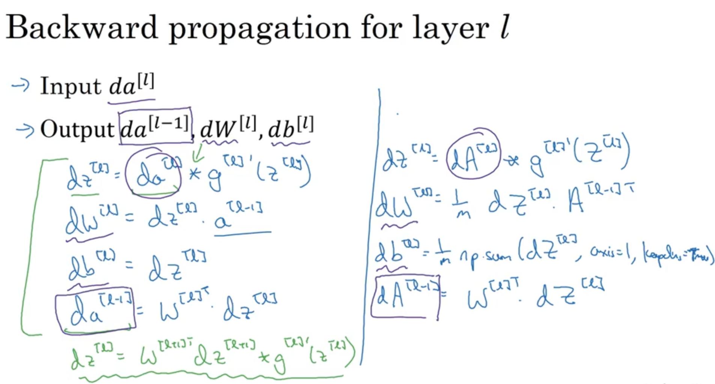

* 1. Summary
     1. **dA[l] = (-y(1) / a(1) + (1-y(1))/(1-a(1)) …-y(m)/a(m) + (1-y(m)) / (1-a(m)))**

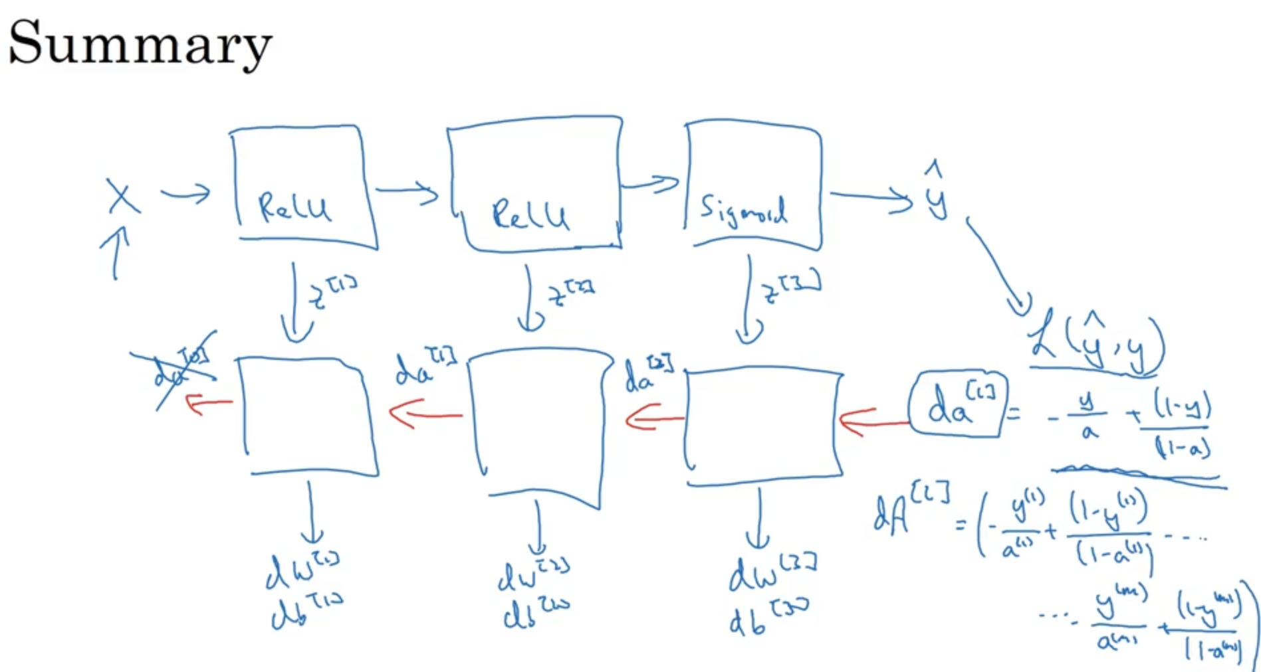

1. Hyperparameters
   1. Parameters: W,B
   2. Hyperparameters:
      1. Learning rate alpha
      2. Iterations
      3. Hidden Layers L
      4. Hidden Units: n[1], n[2], …
      5. Choice Activation functions
   3. Later (next course): momentum, mini-batch size, regularization
   4. Applying DL mean try different parameters and try again.

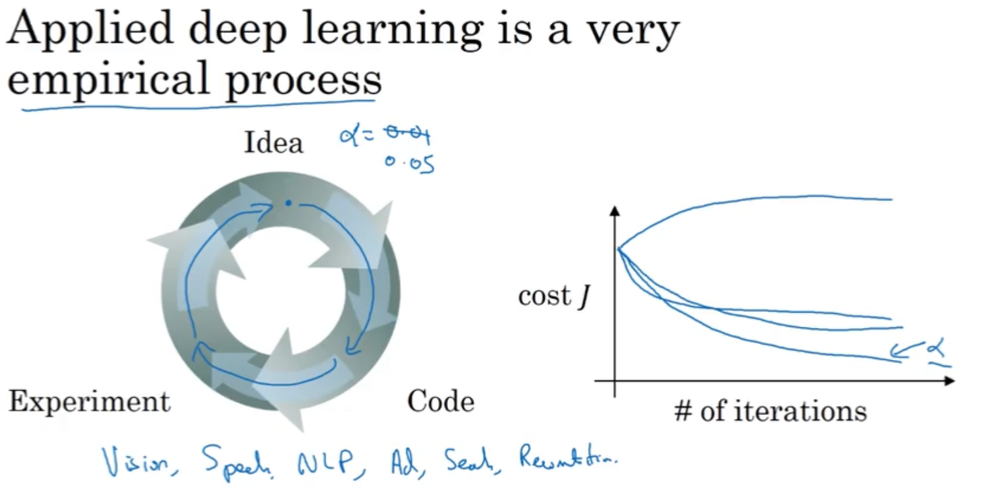

1. What does NN has to do with the human brain? Not a lot.

